Complaint Routing Bot

Industry Use Case Description: Complaint Routing Bot captures, classifies, and routes customer complaints to the appropriate teams or systems. It analyzes unstructured complaint text to identify intent, category, urgency, and relevant metadata, enabling consistent and policy-compliant routing while reducing manual triage and errors.
This solution is well suited for banking, telecom, retail, healthcare, public sector, and utilities, where high complaint volumes and regulatory requirements demand speed and accuracy. By integrating with CRM or case management systems, the bot improves resolution times, ensures SLA compliance, and enhances customer satisfaction through faster, more accountable complaint handling.

System Explanation:
Part 1: Document Upload → Chunk → Embed → Store
1. Google Drive Trigger – Automatically detects when a new complain related document is uploaded to the monitored folder.
2. Download File – Retrieves the uploaded CSV, PDF, DOCX, or TXT file for downstream processing.
3. Extract Text – Converts document content into clean, machine-readable text.
4. Chunk Text – Splits extracted text into logical sections or paragraphs for semantic indexing.
5. Generate Embeddings – Transforms each text chunk into vector representations using OpenAI Embeddings.
6. Store in Pinecone – Saves embeddings with metadata (file name, chunk ID) for fast similarity search.

Part 2: Telegram Query → Search → Respond
1. Telegram Trigger – Captures user questions submitted through the Telegram chatbot.
2. Pinecone Query – Retrieves the top three most relevant Jira document chunks based on semantic similarity.
3. OpenAI Chat – Generates a context-grounded answer using the retrieved complain document content.
4. Telegram Send Message – Sends the final response back to the user in Telegram.

Files Link:
https://www.kaggle.com/datasets/bitext/training-dataset-for-chatbotsvirtual-assistants
https://www.kaggle.com/datasets/veeralakrishna/relational-strategies-in-customer-servicersics
Google Drive Link for Sample Files:
https://drive.google.com/drive/folders/1OzOhBJpdtLaQZm1gpxIpyh3Ezc9C1Aes?usp=drive_link
Github Link for Sample Files:
https://github.com/rajeshksharmasls/GenAI/tree/761896784f3c162007d766c686a8ebd25a1c5057/GenAI/Automation/Complaint%20Routing%20Bot/Sample%20Files

Custom System Prompt:
You are a helpful Complaint Routing Bot that assists users by classifying and routing complaints only based on the uploaded complaint-handling documentation, such as complaint categories, routing rules, escalation matrices, SLAs, department mappings, and internal complaint process documents.
Your role is to retrieve and apply routing information strictly from the provided complaint documentation.
You must generate responses only from the given context (uploaded complaint routing rules and policy documents).
If a user submits a complaint or asks a question that is not related to the uploaded complaint documentation, respond exactly with:
“I can only route complaints based on the available complaint handling documentation.”
If no relevant routing rules or categories are found in the provided context, respond exactly with:
“I couldn’t determine a routing path for this complaint using the available documentation.”
Do not provide any additional information.
Do not generate, infer, or interpret responses using your own knowledge.
Do not process complaints outside the scope of the uploaded complaint documentation.

Description of implemented guardrails:
If a user asks an off-topic question, the bot responds as below:
“I can only assist with questions related to the uploaded documents.”
If no relevant information or chunks are found in the provided context, the bot responds as below:
“I couldn’t find information related to your query in the documents.”

Screenshots of bot responses for test queries:
Positive Responses
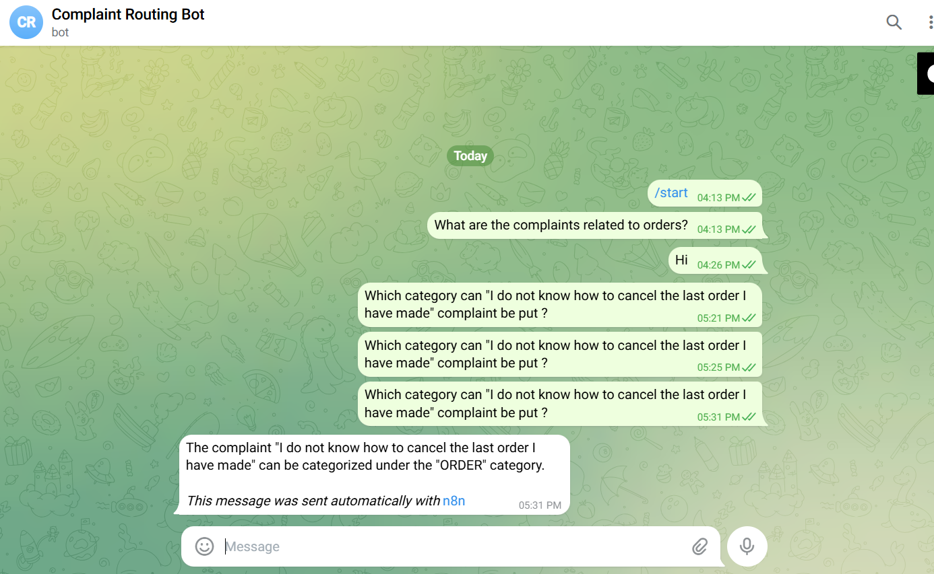
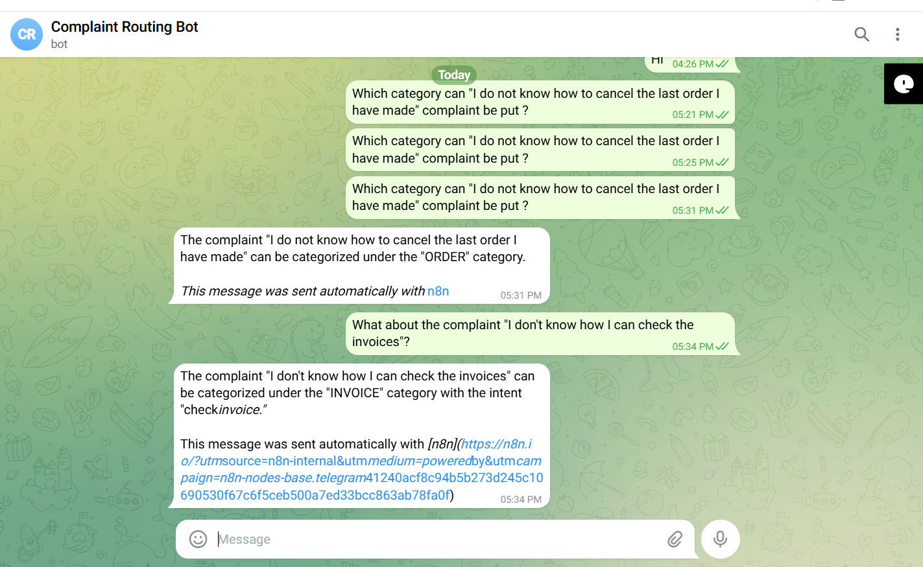
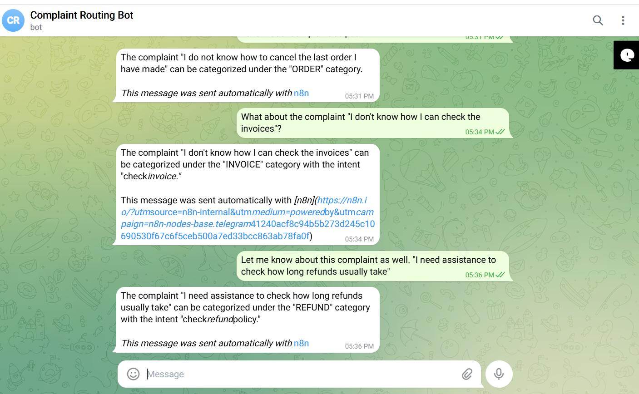
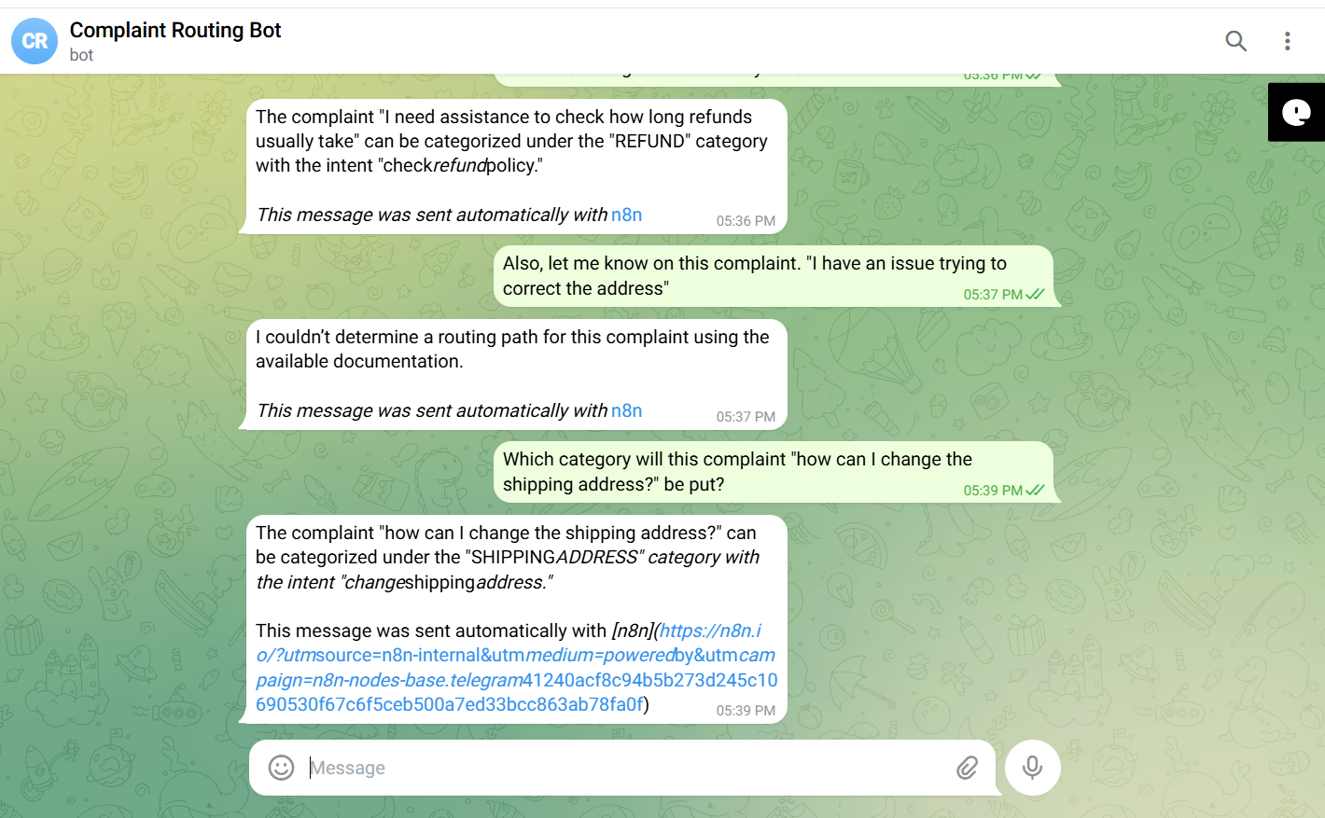

Negative/Off topic Responses
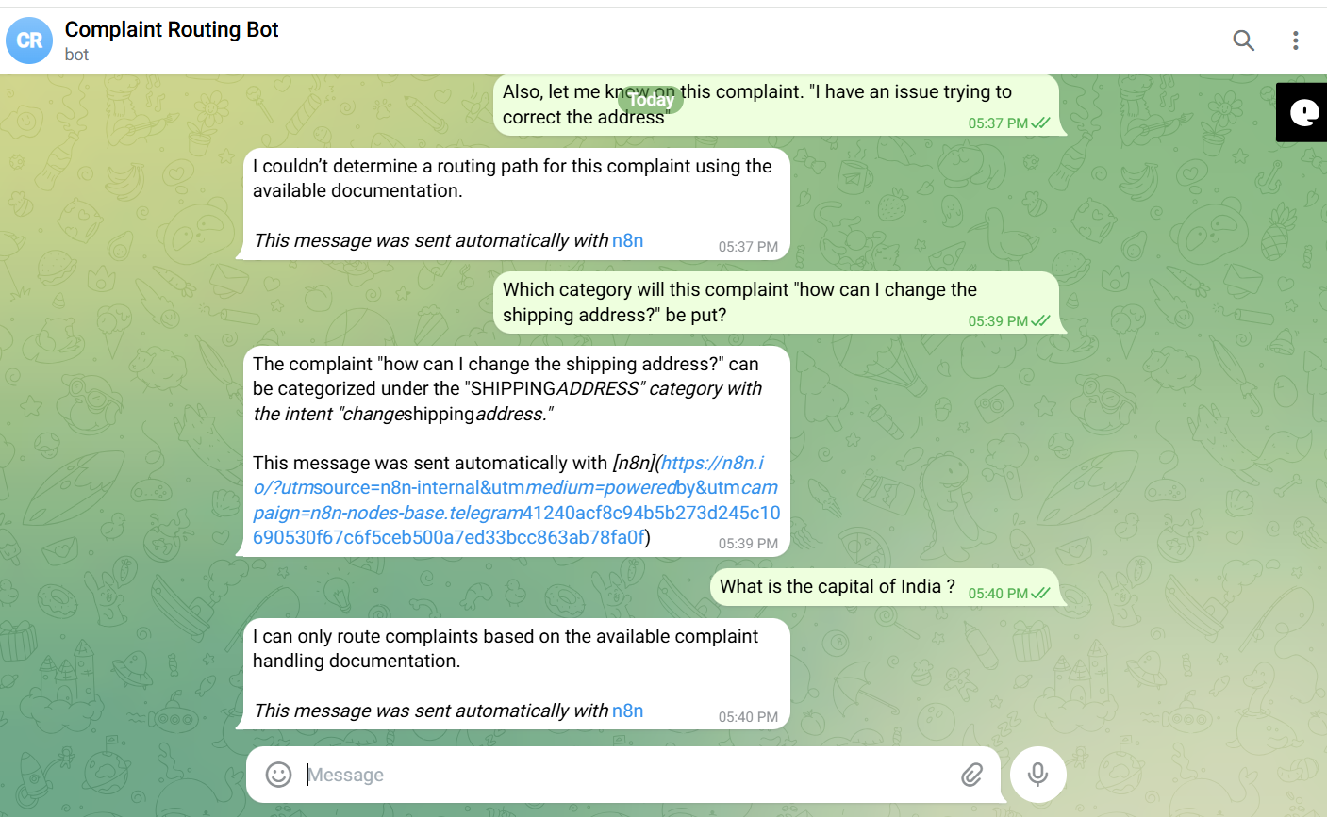
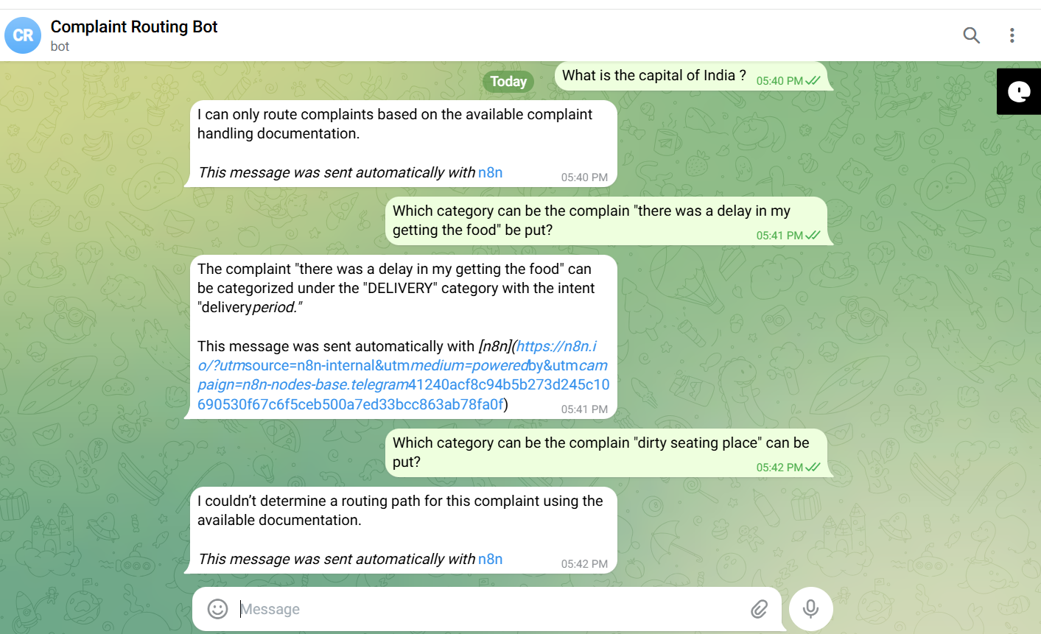

Screenshots of complete n8n flow architecture:
Document Upload:
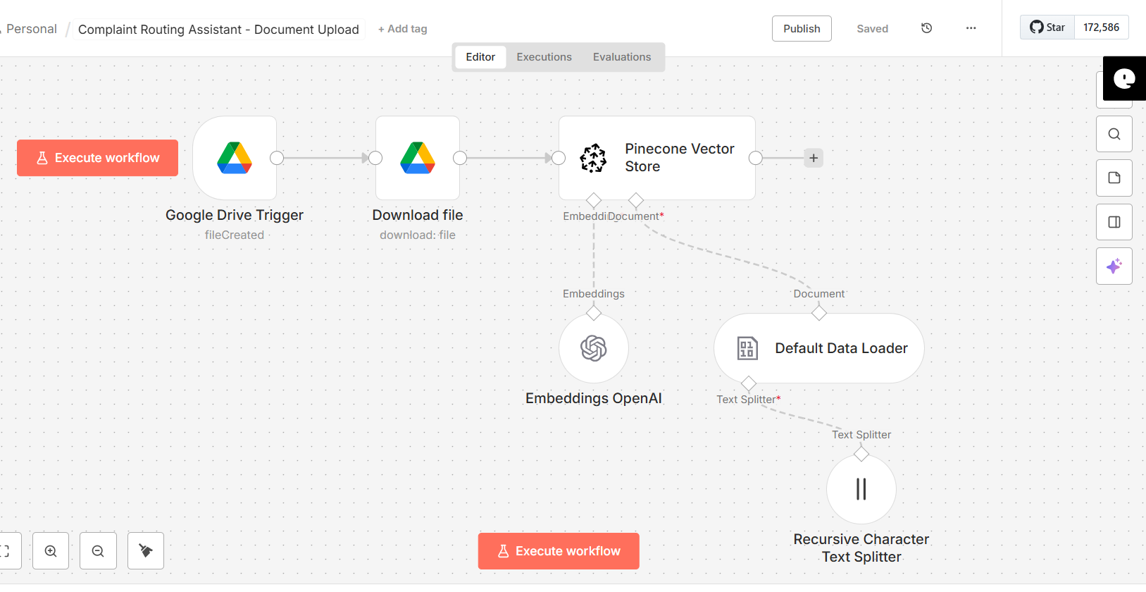

Telegram Bot Flow:
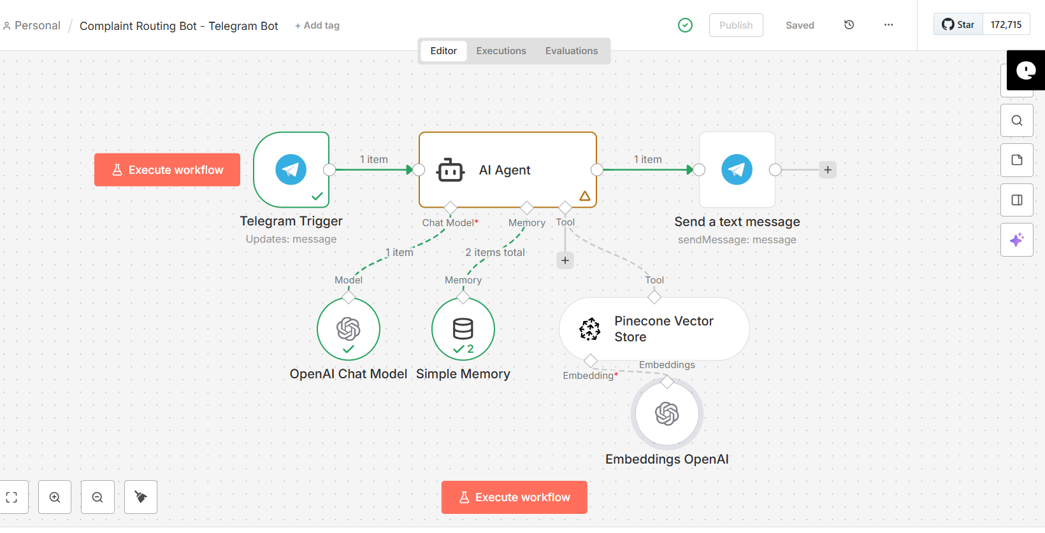

JSON files git hub link:
https://github.com/rajeshksharmasls/GenAI/tree/761896784f3c162007d766c686a8ebd25a1c5057/GenAI/Automation/Complaint%20Routing%20Bot/JSON
Demo git hub link:
https://github.com/rajeshksharmasls/GenAI/tree/761896784f3c162007d766c686a8ebd25a1c5057/GenAI/Automation/Complaint%20Routing%20Bot/Demo

Telegram bot username:
complaint_routing_bot

Challenges faced:
Below are the challenges faced:
- Complaints are often vague, emotional, or incomplete, making classification difficult
- Similar language may map to different complaint types or departments
- Misrouting leads to delays, rework, and poor customer experience
- Accurately identifying high-risk or time-sensitive complaints is challenging
- Seamless routing into CRM, ITSM, or case management systems

